City of Bastrop Permit Requirements

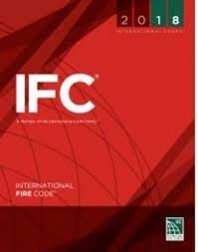

International Fire Code (IFC)

105.1.1 Permits required.
A property owner or owner’s authorized agent who intends to conduct an operation or business, or install or modify systems and equipment that are regulated by this code, or to cause any such work to be performed, shall first make application to the fire code official and obtain the required permit.

105.1.2 Types of permits.
There shall be two types of permits as follows:
- Operational permit. An operational permit allows the applicant to conduct an operation or a business for which a permit is required by Section 105.5 Required operational permits for either:
  - A prescribed period.
  - Until renewed or revoked.
- Construction permit. A construction permit allows the applicant to install or modify systems and equipment for which a permit is required by Section 105.6.

